NAME – Dhrish.S.Kumar

UNIQUE ID – E0320008

**LAB4**

Installation of openvas:

Step 1: Open kali linux terminal and type the following command.

Step 2: After that, update the destro to new version.

Apt-get upgrade Or Apt-get dest –upgrade

Procedure:

Step 1: Open openvas by typing.

Openvas-start in terminal

Step 2: During first time it will show credentials in terminal.

User-name: Admin

Password: xxx-xxx

Save those on somewhere

Step 3: After that browser will be open automatically prompting the login screen if not [type following address in any browser].

https://127.0.0.1:9392(login page will appear)

Step 4: Now Dashboard page will be open listing major vulnerabilities on the network on Menu bar click on scans bar.

Step 5: On scans click on tasks to create a new task/scan.

Step 6: On task page, there will be a task wizard on topleft corner.

Step 7: It will prompt you enter IP address or hostname to starscan.

Or

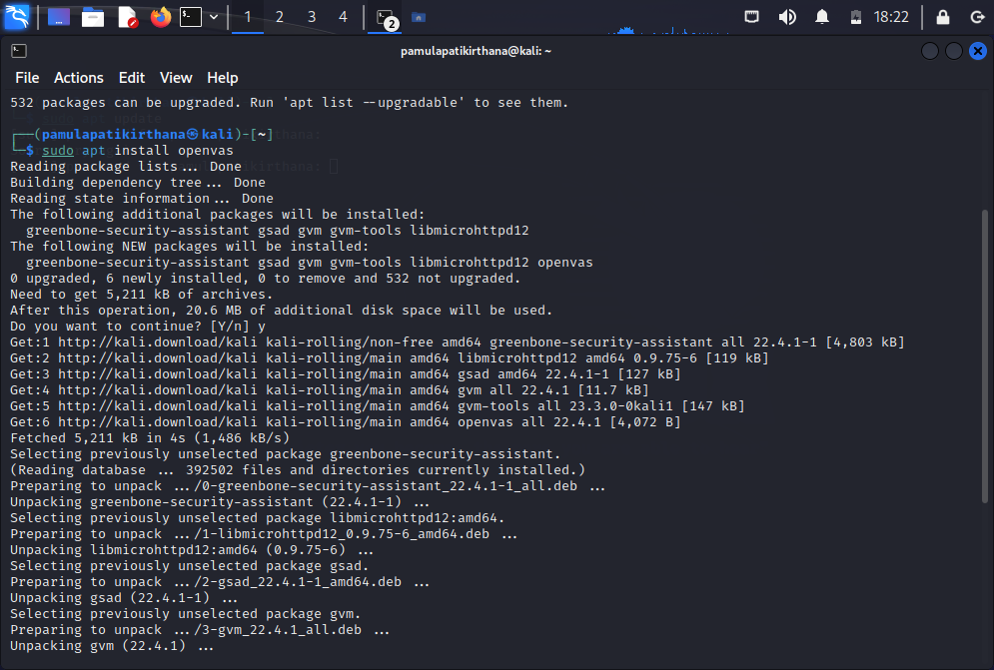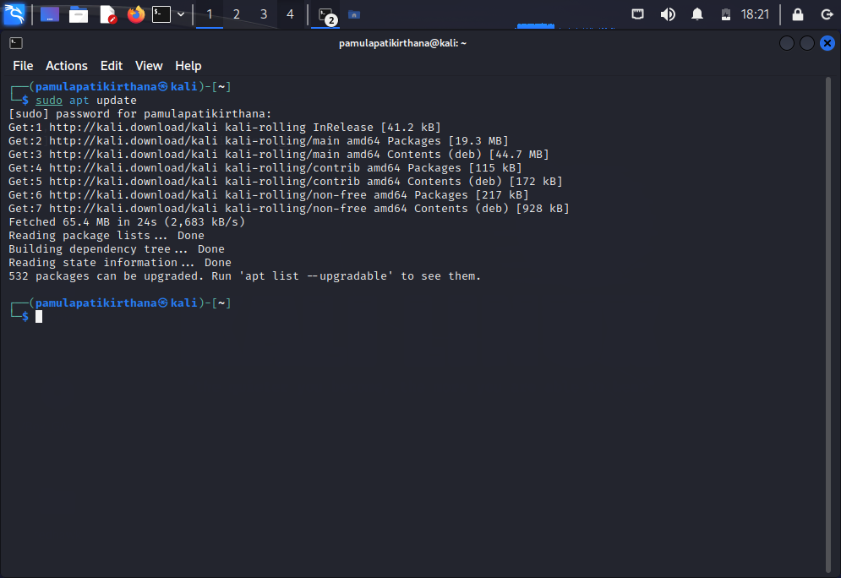Click on advanced task wizard (on hovering on task wizard icon).

